
KABARAK UNIVERSITY

UNIVERSITY EXAMINATIONS
ONLINE
FIRST SEMESTER 2025, ACADEMIC YEAR

FOR THE DEGREE OF BACHELOR OF SCIENCE IN I.T
FORENSICS/COMPUTER SCIENCE
COSF 413/COMP 413 ARTIFICIAL INTELLIGENCE
STREAM: Y4S1 TIME: 2HRS
EXAMINATION SESSION: APRIL DATE : …………
INSTRUCTIONS TO CANDIDATES
- Answer Question 1 and any other two questions in the answer booklet provided.
- Do not write on your question papers. All rough work should be done in your answer booklet.
- Clearly indicate which question you are answering.
- Write neatly and legibly.
- Follow all the instructions in the answer booklet

SECTION A: (Compulsory) TOTAL MARKS FOR THIS SECTION IS 30.

- ANN is a computing system made up of a number of simple, highly interconnected processing elements. Using a diagram describe convolutional neural network (6marks)
- A neuron with 4 inputs has the weight vector w = [1, 2, 3, 4]^{T} and a bias θ = 0 (zero). The activation function is linear, where the constant of proportionality equals 2 ,that is, the activation function is given by f(net) = 2 × net. If the input vector is x = [4, 8, 5, 6]^{T} .Calculate the output of the Neuron. (6marks)
- Explain the following.
- Tensorflow (2marks)
- Eli5 (2marks)
- pandas (2marks)

- Differentiate between the following as used in problem solving by search
- Open list vs closed list (3marks)
- Informed vs uninformed search (3marks)
- Evaluation function vs heuristic function (3marks)
- Using A star search find the optimal path that will connect node A to G (3marks)
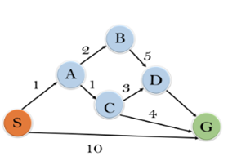

QUESTION TWO [20 MARKS]
- Suppose you are given the following data set in CSV format
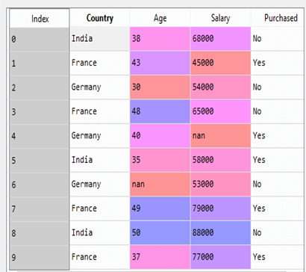
- Write a python program to load the data set make assumption where necessary (7marks)
- Write a program to exclude dependent variable (5marks)
b) A genetic algorithm is a search heuristic that is inspired by Charles Darwin’s theory of natural evolution. Discuss the phases of genetic algorithm (8marks)
QUESTION THREE [20 MARKS]
- Using examples explain the meaning of the following in NLP terms (10marks)
- Stemming
- Stop words
- One hot encoding
- Dimension reduction
- Feature engineering
- List the steps in NLP process (5marks)
- Adversarial search is a search, where we examine the problem which arises when we try to plan ahead of the world and other agents are planning against us. Explain the following adversarial search algorithms
- Min-max algorithm (2.5marks)
ii. Alpha beta pruning algorithm (2.5marks)

QUESTION FOUR [20 MARKS]

- A patient has been suffering from shortness of breath (called dyspnea) and visits the doctor, worried that he has lung cancer. The doctor knows that other diseases, such as tuberculosis and bronchitis are possible causes, as well as lung cancer. She also knows that other relevant information includes whether or not the patient is a smoker (increasing the chances of cancer and bronchitis) and what sort of air pollution he has been exposed to. A positive X-Ray would indicate either TB or lung cancer.

i) What are the nodes to represent and what values can they take? (6marks)
ii)Prepare a conditional probability table(CPT) for the above scenario (6 marks)
- Machine learning is a part of AI which provides intelligence to machines with the ability to automatically learn with experiences without being explicitly programmed, list and explain the types of machine learning (8 marks)

QUESTION FIVE [20MARKS]
a) Consider the problem of finding the shortest route through several Towns, such that each town is visited only once and in the end return to the starting town ( Travelling Salesman Problem). Suppose that in order to solve this problem we use a genetic algorithm, in which genes represent links between pairs of town. For example, a link between Nairobi and Kisumu is represented by a single gene ‘NK’. Assume that the direction in which we travel is not important so that NK = KN.
i) How many genes will be used in a chromosome of each individual if the number of towns is 5? (7 marks)
ii) How many genes will be in the alphabet of the algorithm? (5marks)
- Suppose, we have an image of a creature that looks similar to cat and dog, and we want to know whether it is a cat or dog, which machine learning algorithm is suitable for this scenario. Explain (5marks)
- Explain why OpenCV is suitable for computer vision (3marks)

